CNN Model:

import os

import glob

import soundfile

import numpy as np

import librosa

import tensorflow as tf

from tensorflow.keras import layers, models, Input

from sklearn.model_selection import train_test_split

from sklearn.metrics import classification_report, confusion_matrix

from tensorflow.keras.utils import to_categorical

import matplotlib.pyplot as plt

import seaborn as sns

from tensorflow.keras.callbacks import EarlyStopping, ReduceLROnPlateau

#######################################

# Configuration

#######################################

DATA_PATH = "/content/drive/MyDrive/Speech Recognition - Maha/Ravadess/Actor_*/*.wav"

N_MFCC = 40

MAX_FRAMES = 128

SAMPLE_RATE = 22050

AVAILABLE_EMOTIONS = {"angry", "sad", "neutral", "happy"}

label_map = {'happy':0, 'sad':1, 'neutral':2, 'angry':3}

int2emotion = {

"01": "neutral",

"02": "calm",

"03": "happy",

"04": "sad",

"05": "angry",

"06": "fearful",

"07": "disgust",

"08": "surprised"

}

#######################################

# Feature Extraction as Sequence

#######################################

def extract_mfcc_2d(file_path, n_mfcc=40, max_frames=128, sr=22050):

try:

with soundfile.SoundFile(file_path) as sf:

audio = sf.read(dtype='float32')

file_sr = sf.samplerate

# If too short, skip

if len(audio) < 2048:

return None

# Resample if needed

if file_sr != sr:

audio = librosa.resample(audio, orig_sr=file_sr, target_sr=sr)

mfcc = librosa.feature.mfcc(y=audio, sr=sr, n_mfcc=n_mfcc) # shape: [n_mfcc, frames]

mfcc = mfcc.T # now shape: [frames, n_mfcc]

if mfcc.shape[0] == 0:

return None

# Pad or truncate

if mfcc.shape[0] < max_frames:

pad_width = max_frames - mfcc.shape[0]

mfcc = np.pad(mfcc, ((0,pad_width),(0,0)), mode='constant')

else:

mfcc = mfcc[:max_frames, :]

return mfcc

except Exception as e:

print(f"Error processing {file_path}: {e}")

return None

def load_data(test_size=0.2):

X, y = [], []

for file in glob.glob(DATA_PATH):

basename = os.path.basename(file)

emotion_code = basename.split("-")[2]

if emotion_code not in int2emotion:

continue

emotion = int2emotion[emotion_code]

if emotion not in AVAILABLE_EMOTIONS:

continue

mfcc = extract_mfcc_2d(file_path=file, n_mfcc=N_MFCC, max_frames=MAX_FRAMES, sr=SAMPLE_RATE)

if mfcc is None:

continue

X.append(mfcc)

y.append(label_map[emotion])

X = np.array(X) # shape: [samples, MAX_FRAMES, N_MFCC]

y = np.array(y)

return train_test_split(X, y, test_size=test_size, random_state=42, stratify=y)

#######################################

# Load Data

#######################################

X_train, X_test, y_train, y_test = load_data(test_size=0.2)

print("Training samples:", X_train.shape[0])

print("Testing samples:", X_test.shape[0])

num_classes = len(label_map)

y_train_oh = to_categorical(y_train, num_classes=num_classes)

y_test_oh = to_categorical(y_test, num_classes=num_classes)

#######################################

# Transformer Encoder Block

#######################################

def transformer_encoder(x, num_heads, ff_dim, dropout=0.1, d_model=64):

attn_output = layers.MultiHeadAttention(num_heads=num_heads, key_dim=d_model, dropout=dropout)(x, x)

attn_output = layers.Dropout(dropout)(attn_output)

x = layers.LayerNormalization(epsilon=1e-6)(x + attn_output)

ffn = models.Sequential([

layers.Dense(ff_dim, activation='relu'),

layers.Dense(d_model)

])

ffn_output = ffn(x)

ffn_output = layers.Dropout(dropout)(ffn_output)

x = layers.LayerNormalization(epsilon=1e-6)(x + ffn_output)

return x

#######################################

# Build Transformer Model

#######################################

def build_transformer_model(sequence_length, feature_dim, num_classes, d_model=64, num_heads=4, ff_dim=128, num_layers=2, dropout=0.1):

inputs = Input(shape=(sequence_length, feature_dim)) # (batch, MAX_FRAMES, N_MFCC)

# Create a trainable positional embedding

# Positions: [0 ... sequence_length-1]

pos_embedding_layer = layers.Embedding(input_dim=sequence_length, output_dim=d_model)

positions = tf.range(start=0, limit=sequence_length, delta=1)

pos_emb = pos_embedding_layer(positions) # (sequence_length, d_model)

pos_emb = tf.expand_dims(pos_emb, axis=0) # (1, sequence_length, d_model)

# Project input features to d_model dimension

x = layers.Dense(d_model)(inputs)

# Add positional encoding by broadcasting pos_emb to match batch size at runtime.

x = x + pos_emb

# Stacking multiple transformer encoder layers

for _ in range(num_layers):

x = transformer_encoder(x, num_heads=num_heads, ff_dim=ff_dim, dropout=dropout, d_model=d_model)

# Global Average Pooling

x = layers.GlobalAveragePooling1D()(x)

x = layers.Dropout(dropout)(x)

outputs = layers.Dense(num_classes, activation='softmax')(x)

model = models.Model(inputs=inputs, outputs=outputs)

model.compile(optimizer='adam', loss='categorical_crossentropy', metrics=['accuracy'])

return model

model = build_transformer_model(sequence_length=MAX_FRAMES, feature_dim=N_MFCC, num_classes=num_classes, d_model=64, num_heads=4, ff_dim=128, num_layers=2, dropout=0.1)

model.summary()

#######################################

# Train the Model

#######################################

early_stop = EarlyStopping(monitor='val_loss', patience=10, restore_best_weights=True)

reduce_lr = ReduceLROnPlateau(monitor='val_loss', factor=0.2, patience=5, min_lr=1e-5)

history = model.fit(

X_train, y_train_oh,

epochs=50,

batch_size=32,

validation_data=(X_test, y_test_oh),

callbacks=[early_stop, reduce_lr],

verbose=1

)

#######################################

# Evaluate the Model

#######################################

loss, acc = model.evaluate(X_test, y_test_oh, verbose=0)

print(f"Test Accuracy: {acc*100:.2f}%")

# Plot training history

plt.figure(figsize=(14,5))

# Accuracy

plt.subplot(1,2,1)

plt.plot(history.history['accuracy'], label='Train Accuracy')

plt.plot(history.history['val_accuracy'], label='Val Accuracy')

plt.title('Model Accuracy')

plt.xlabel('Epoch')

plt.ylabel('Accuracy')

plt.legend()

# Loss

plt.subplot(1,2,2)

plt.plot(history.history['loss'], label='Train Loss')

plt.plot(history.history['val_loss'], label='Val Loss')

plt.title('Model Loss')

plt.xlabel('Epoch')

plt.ylabel('Loss')

plt.legend()

plt.show()

#######################################

# Classification Report

#######################################

y_pred = model.predict(X_test)

y_pred_classes = np.argmax(y_pred, axis=1)

reverse_label_map = {v:k for k,v in label_map.items()}

class_names = [reverse_label_map[i] for i in range(num_classes)]

print("Classification Report:")

print(classification_report(y_test, y_pred_classes, target_names=class_names))

cm = confusion_matrix(y_test, y_pred_classes)

plt.figure(figsize=(10,8))

sns.heatmap(cm, annot=True, fmt='d', cmap='Blues',

xticklabels=class_names,

yticklabels=class_names)

plt.title('Confusion Matrix')

plt.xlabel('Predicted')

plt.ylabel('Actual')

plt.show()

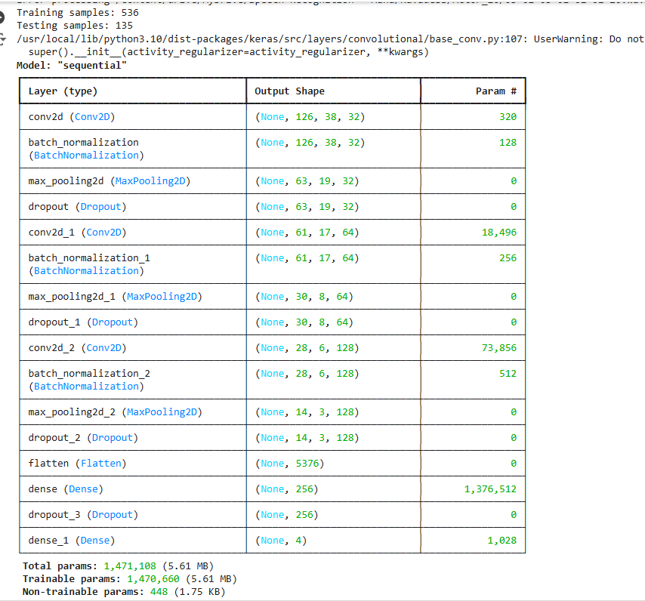

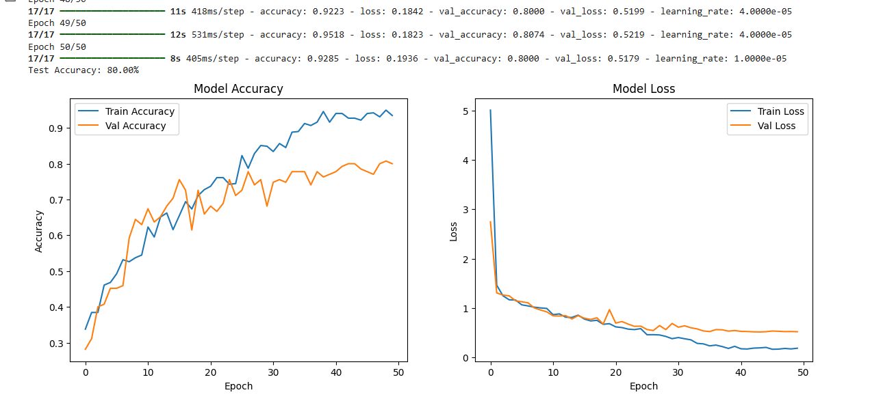

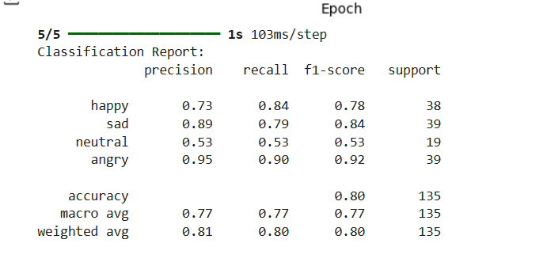

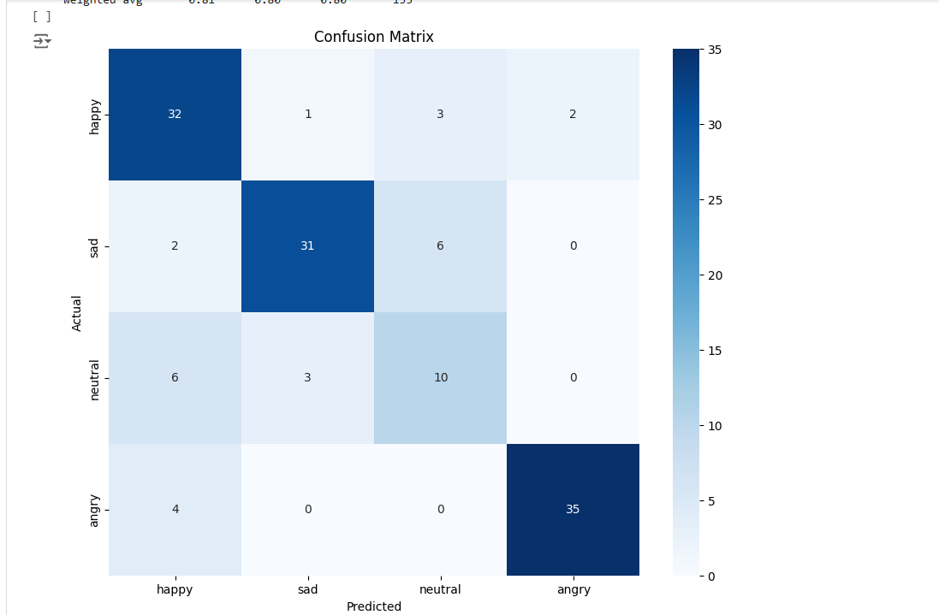

ResNet Model:

import os

import glob

import soundfile

import numpy as np

import librosa

from sklearn.model_selection import train_test_split

from sklearn.metrics import classification_report, confusion_matrix

from tensorflow.keras.utils import to_categorical

from tensorflow.keras import layers, models, Input

import matplotlib.pyplot as plt

import seaborn as sns

from tensorflow.keras.callbacks import EarlyStopping, ReduceLROnPlateau

#######################################

# Configuration

#######################################

DATA_PATH = "/content/drive/MyDrive/Speech Recognition - Maha/Ravadess/Actor_*/*.wav"

N_MFCC = 40 # number of MFCC coefficients

MAX_FRAMES = 128 # max number of frames we’ll keep for each sample

SAMPLE_RATE = 22050

AVAILABLE_EMOTIONS = {"angry", "sad", "neutral", "happy"}

label_map = {'happy':0, 'sad':1, 'neutral':2, 'angry':3}

int2emotion = {

"01": "neutral",

"02": "calm",

"03": "happy",

"04": "sad",

"05": "angry",

"06": "fearful",

"07": "disgust",

"08": "surprised"

}

#######################################

# Feature Extraction as 2D Input

#######################################

def extract_mfcc_2d(file_path, n_mfcc=40, max_frames=128, sr=22050):

try:

with soundfile.SoundFile(file_path) as sf:

audio = sf.read(dtype='float32')

file_sr = sf.samplerate

# If too short, skip

if len(audio) < 2048:

return None

# Resample if needed

if file_sr != sr:

audio = librosa.resample(audio, orig_sr=file_sr, target_sr=sr)

# Extract MFCCs

mfcc = librosa.feature.mfcc(y=audio, sr=sr, n_mfcc=n_mfcc) # shape: [n_mfcc, frames]

mfcc = mfcc.T # shape: [frames, n_mfcc]

if mfcc.shape[0] == 0:

return None

# Pad or truncate

if mfcc.shape[0] < max_frames:

pad_width = max_frames - mfcc.shape[0]

mfcc = np.pad(mfcc, ((0,pad_width),(0,0)), mode='constant')

else:

mfcc = mfcc[:max_frames, :]

return mfcc

except Exception as e:

print(f"Error processing {file_path}: {e}")

return None

def load_data(test_size=0.2):

X, y = [], []

for file in glob.glob(DATA_PATH):

basename = os.path.basename(file)

emotion_code = basename.split("-")[2]

if emotion_code not in int2emotion:

continue

emotion = int2emotion[emotion_code]

if emotion not in AVAILABLE_EMOTIONS:

continue

mfcc = extract_mfcc_2d(file_path=file, n_mfcc=N_MFCC, max_frames=MAX_FRAMES, sr=SAMPLE_RATE)

if mfcc is None:

continue

X.append(mfcc)

y.append(label_map[emotion])

X = np.array(X) # shape: [samples, frames, n_mfcc]

y = np.array(y)

return train_test_split(X, y, test_size=test_size, random_state=42, stratify=y)

#######################################

# Load the Data

#######################################

X_train, X_test, y_train, y_test = load_data(test_size=0.2)

print("Training samples:", X_train.shape[0])

print("Testing samples:", X_test.shape[0])

# Add channel dimension for CNN/ResNet: (samples, frames, n_mfcc, 1)

X_train = X_train[..., np.newaxis]

X_test = X_test[..., np.newaxis]

num_classes = len(label_map)

y_train_oh = to_categorical(y_train, num_classes=num_classes)

y_test_oh = to_categorical(y_test, num_classes=num_classes)

#######################################

# Residual Block Definition

#######################################

def residual_block(x, filters, kernel_size=(3,3)):

# First conv layer

shortcut = x

x = layers.Conv2D(filters, kernel_size, padding='same', activation='relu')(x)

x = layers.BatchNormalization()(x)

# Second conv layer

x = layers.Conv2D(filters, kernel_size, padding='same', activation=None)(x)

x = layers.BatchNormalization()(x)

# Add the shortcut (input) back

x = layers.Add()([x, shortcut])

x = layers.Activation('relu')(x)

return x

#######################################

# Build a Simple ResNet-like Model

#######################################

def build_resnet(input_shape, num_classes):

inputs = Input(shape=input_shape)

# Initial Conv layer

x = layers.Conv2D(32, (3,3), activation='relu', padding='same')(inputs)

x = layers.BatchNormalization()(x)

# First residual block

x = residual_block(x, 32)

x = layers.MaxPooling2D((2,2))(x)

x = layers.Dropout(0.25)(x)

# Second residual block

x = layers.Conv2D(64, (3,3), padding='same', activation='relu')(x)

x = layers.BatchNormalization()(x)

x = residual_block(x, 64)

x = layers.MaxPooling2D((2,2))(x)

x = layers.Dropout(0.25)(x)

# Third residual block

x = layers.Conv2D(128, (3,3), padding='same', activation='relu')(x)

x = layers.BatchNormalization()(x)

x = residual_block(x, 128)

x = layers.MaxPooling2D((2,2))(x)

x = layers.Dropout(0.25)(x)

x = layers.Flatten()(x)

x = layers.Dense(256, activation='relu')(x)

x = layers.Dropout(0.5)(x)

outputs = layers.Dense(num_classes, activation='softmax')(x)

model = models.Model(inputs, outputs)

model.compile(optimizer='adam', loss='categorical_crossentropy', metrics=['accuracy'])

return model

model = build_resnet((MAX_FRAMES, N_MFCC, 1), num_classes)

model.summary()

#######################################

# Train the Model

#######################################

early_stop = EarlyStopping(monitor='val_loss', patience=10, restore_best_weights=True)

reduce_lr = ReduceLROnPlateau(monitor='val_loss', factor=0.2, patience=5, min_lr=1e-5)

history = model.fit(

X_train, y_train_oh,

epochs=50,

batch_size=32,

validation_data=(X_test, y_test_oh),

callbacks=[early_stop, reduce_lr],

verbose=1

)

#######################################

# Evaluate the Model

#######################################

loss, acc = model.evaluate(X_test, y_test_oh, verbose=0)

print(f"Test Accuracy: {acc*100:.2f}%")

# Plot training history

plt.figure(figsize=(14,5))

# Accuracy

plt.subplot(1,2,1)

plt.plot(history.history['accuracy'], label='Train Accuracy')

plt.plot(history.history['val_accuracy'], label='Val Accuracy')

plt.title('Model Accuracy')

plt.xlabel('Epoch')

plt.ylabel('Accuracy')

plt.legend()

# Loss

plt.subplot(1,2,2)

plt.plot(history.history['loss'], label='Train Loss')

plt.plot(history.history['val_loss'], label='Val Loss')

plt.title('Model Loss')

plt.xlabel('Epoch')

plt.ylabel('Loss')

plt.legend()

plt.show()

#######################################

# Classification Report

#######################################

y_pred = model.predict(X_test)

y_pred_classes = np.argmax(y_pred, axis=1)

reverse_label_map = {v:k for k,v in label_map.items()}

class_names = [reverse_label_map[i] for i in range(num_classes)]

print("Classification Report:")

print(classification_report(y_test, y_pred_classes, target_names=class_names))

cm = confusion_matrix(y_test, y_pred_classes)

plt.figure(figsize=(10,8))

sns.heatmap(cm, annot=True, fmt='d', cmap='Blues',

xticklabels=class_names,

yticklabels=class_names)

plt.title('Confusion Matrix')

plt.xlabel('Predicted')

plt.ylabel('Actual')

plt.show()

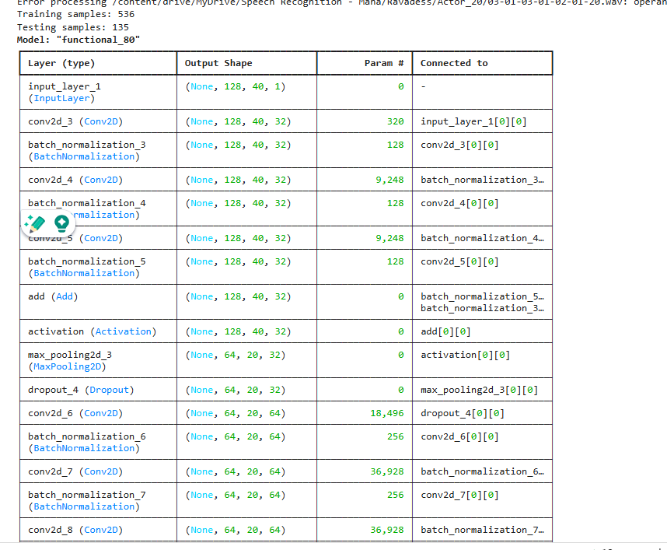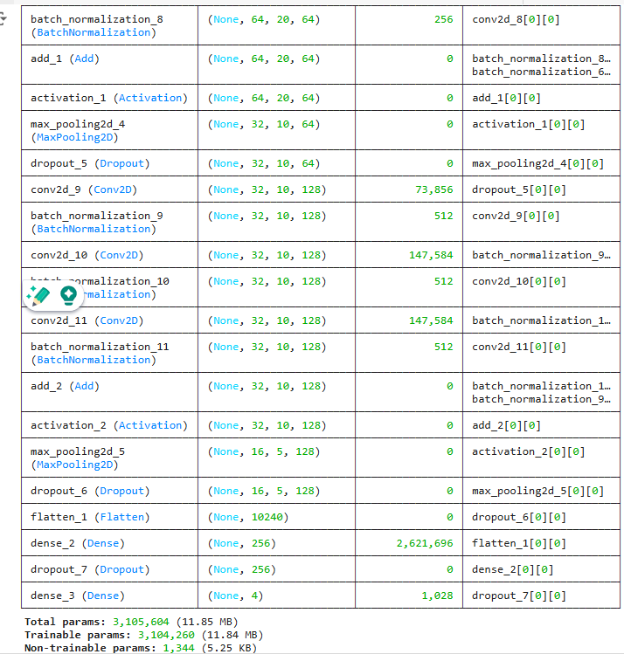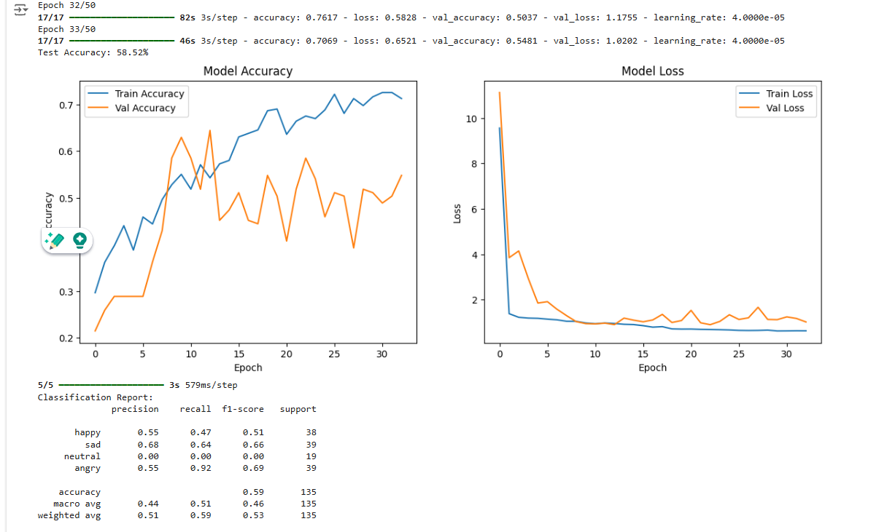

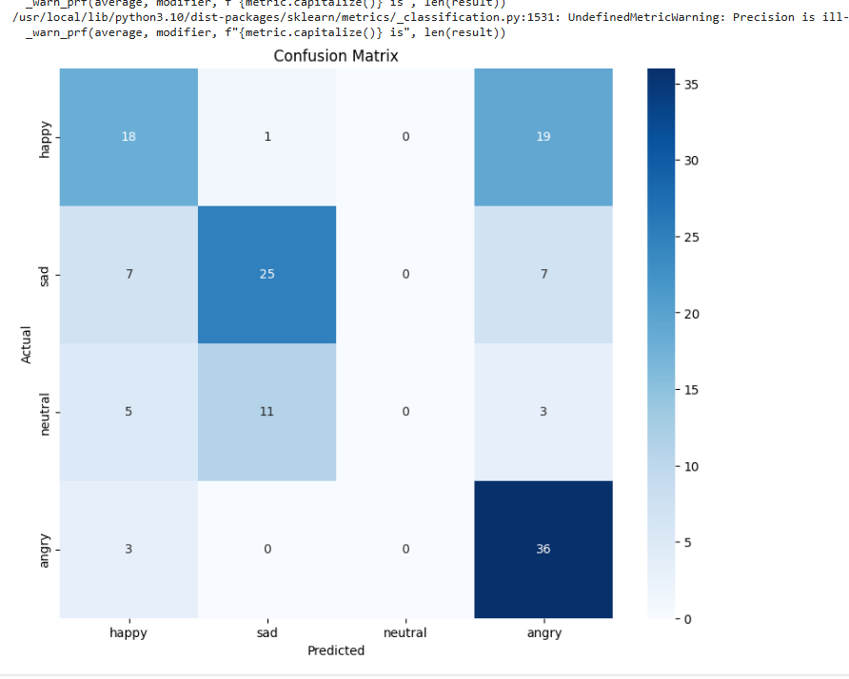

Transformer based Model:

import os

import glob

import soundfile

import numpy as np

import librosa

import tensorflow as tf

from tensorflow.keras import layers, models, Input

from sklearn.model_selection import train_test_split

from sklearn.metrics import classification_report, confusion_matrix

from tensorflow.keras.utils import to_categorical

import matplotlib.pyplot as plt

import seaborn as sns

from tensorflow.keras.callbacks import EarlyStopping, ReduceLROnPlateau

#######################################

# Configuration

#######################################

DATA_PATH = "/content/drive/MyDrive/Speech Recognition - Maha/Ravadess/Actor_*/*.wav"

N_MFCC = 40

MAX_FRAMES = 128

SAMPLE_RATE = 22050

AVAILABLE_EMOTIONS = {"angry", "sad", "neutral", "happy"}

label_map = {'happy':0, 'sad':1, 'neutral':2, 'angry':3}

int2emotion = {

"01": "neutral",

"02": "calm",

"03": "happy",

"04": "sad",

"05": "angry",

"06": "fearful",

"07": "disgust",

"08": "surprised"

}

#######################################

# Feature Extraction as Sequence

#######################################

def extract_mfcc_2d(file_path, n_mfcc=40, max_frames=128, sr=22050):

try:

with soundfile.SoundFile(file_path) as sf:

audio = sf.read(dtype='float32')

file_sr = sf.samplerate

# If too short, skip

if len(audio) < 2048:

return None

# Resample if needed

if file_sr != sr:

audio = librosa.resample(audio, orig_sr=file_sr, target_sr=sr)

mfcc = librosa.feature.mfcc(y=audio, sr=sr, n_mfcc=n_mfcc) # shape: [n_mfcc, frames]

mfcc = mfcc.T # now shape: [frames, n_mfcc]

if mfcc.shape[0] == 0:

return None

# Pad or truncate

if mfcc.shape[0] < max_frames:

pad_width = max_frames - mfcc.shape[0]

mfcc = np.pad(mfcc, ((0,pad_width),(0,0)), mode='constant')

else:

mfcc = mfcc[:max_frames, :]

return mfcc

except Exception as e:

print(f"Error processing {file_path}: {e}")

return None

def load_data(test_size=0.2):

X, y = [], []

for file in glob.glob(DATA_PATH):

basename = os.path.basename(file)

emotion_code = basename.split("-")[2]

if emotion_code not in int2emotion:

continue

emotion = int2emotion[emotion_code]

if emotion not in AVAILABLE_EMOTIONS:

continue

mfcc = extract_mfcc_2d(file_path=file, n_mfcc=N_MFCC, max_frames=MAX_FRAMES, sr=SAMPLE_RATE)

if mfcc is None:

continue

X.append(mfcc)

y.append(label_map[emotion])

X = np.array(X) # shape: [samples, MAX_FRAMES, N_MFCC]

y = np.array(y)

return train_test_split(X, y, test_size=test_size, random_state=42, stratify=y)

#######################################

# Load Data

#######################################

X_train, X_test, y_train, y_test = load_data(test_size=0.2)

print("Training samples:", X_train.shape[0])

print("Testing samples:", X_test.shape[0])

num_classes = len(label_map)

y_train_oh = to_categorical(y_train, num_classes=num_classes)

y_test_oh = to_categorical(y_test, num_classes=num_classes)

#######################################

# Transformer Encoder Block

#######################################

def transformer_encoder(x, num_heads, ff_dim, dropout=0.1, d_model=64):

attn_output = layers.MultiHeadAttention(num_heads=num_heads, key_dim=d_model, dropout=dropout)(x, x)

attn_output = layers.Dropout(dropout)(attn_output)

x = layers.LayerNormalization(epsilon=1e-6)(x + attn_output)

ffn = models.Sequential([

layers.Dense(ff_dim, activation='relu'),

layers.Dense(d_model)

])

ffn_output = ffn(x)

ffn_output = layers.Dropout(dropout)(ffn_output)

x = layers.LayerNormalization(epsilon=1e-6)(x + ffn_output)

return x

#######################################

# Build Transformer Model

#######################################

def build_transformer_model(sequence_length, feature_dim, num_classes, d_model=64, num_heads=4, ff_dim=128, num_layers=2, dropout=0.1):

inputs = Input(shape=(sequence_length, feature_dim)) # (batch, MAX_FRAMES, N_MFCC)

# Create a trainable positional embedding

# Positions: [0 ... sequence_length-1]

pos_embedding_layer = layers.Embedding(input_dim=sequence_length, output_dim=d_model)

positions = tf.range(start=0, limit=sequence_length, delta=1)

pos_emb = pos_embedding_layer(positions) # (sequence_length, d_model)

pos_emb = tf.expand_dims(pos_emb, axis=0) # (1, sequence_length, d_model)

# Project input features to d_model dimension

x = layers.Dense(d_model)(inputs)

# Add positional encoding by broadcasting pos_emb to match batch size at runtime.

x = x + pos_emb

# Stacking multiple transformer encoder layers

for _ in range(num_layers):

x = transformer_encoder(x, num_heads=num_heads, ff_dim=ff_dim, dropout=dropout, d_model=d_model)

# Global Average Pooling

x = layers.GlobalAveragePooling1D()(x)

x = layers.Dropout(dropout)(x)

outputs = layers.Dense(num_classes, activation='softmax')(x)

model = models.Model(inputs=inputs, outputs=outputs)

model.compile(optimizer='adam', loss='categorical_crossentropy', metrics=['accuracy'])

return model

model = build_transformer_model(sequence_length=MAX_FRAMES, feature_dim=N_MFCC, num_classes=num_classes, d_model=64, num_heads=4, ff_dim=128, num_layers=2, dropout=0.1)

model.summary()

#######################################

# Train the Model

#######################################

early_stop = EarlyStopping(monitor='val_loss', patience=10, restore_best_weights=True)

reduce_lr = ReduceLROnPlateau(monitor='val_loss', factor=0.2, patience=5, min_lr=1e-5)

history = model.fit(

X_train, y_train_oh,

epochs=50,

batch_size=32,

validation_data=(X_test, y_test_oh),

callbacks=[early_stop, reduce_lr],

verbose=1

)

#######################################

# Evaluate the Model

#######################################

loss, acc = model.evaluate(X_test, y_test_oh, verbose=0)

print(f"Test Accuracy: {acc*100:.2f}%")

# Plot training history

plt.figure(figsize=(14,5))

# Accuracy

plt.subplot(1,2,1)

plt.plot(history.history['accuracy'], label='Train Accuracy')

plt.plot(history.history['val_accuracy'], label='Val Accuracy')

plt.title('Model Accuracy')

plt.xlabel('Epoch')

plt.ylabel('Accuracy')

plt.legend()

# Loss

plt.subplot(1,2,2)

plt.plot(history.history['loss'], label='Train Loss')

plt.plot(history.history['val_loss'], label='Val Loss')

plt.title('Model Loss')

plt.xlabel('Epoch')

plt.ylabel('Loss')

plt.legend()

plt.show()

#######################################

# Classification Report

#######################################

y_pred = model.predict(X_test)

y_pred_classes = np.argmax(y_pred, axis=1)

reverse_label_map = {v:k for k,v in label_map.items()}

class_names = [reverse_label_map[i] for i in range(num_classes)]

print("Classification Report:")

print(classification_report(y_test, y_pred_classes, target_names=class_names))

cm = confusion_matrix(y_test, y_pred_classes)

plt.figure(figsize=(10,8))

sns.heatmap(cm, annot=True, fmt='d', cmap='Blues',

xticklabels=class_names,

yticklabels=class_names)

plt.title('Confusion Matrix')

plt.xlabel('Predicted')

plt.ylabel('Actual')

plt.show()

